Java Technology

Java technology is both a programming language and a platform.

The Java Programming Language
The Java programming language is a high-level language that can be characterized by all of the following characteristics
- Simple
- Object oriented
- Distributed
- Multithreaded
- Architecture neutral
- Portable
- High performance
- Robust

In the Java programming language, all source code is first written in plain text files ending with the .java extension. Those source files are then compiled into .class files by the javac compiler. A .class file does not contain code that is native to your processor; it instead contains bytecodes — the machine language of the Java Virtual Machine1 (Java VM). The java launcher tool then runs your application with an instance of the Java Virtual Machine.
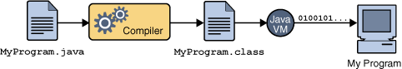
An overview of the software development process.
Because the Java VM is available on many different operating systems, the same .class files are capable of running on Microsoft Windows, the Solaris TM Operating System (Solaris OS), Linux, or Mac OS. Some virtual machines, such as the Java HotSpot virtual machine, perform additional steps at runtime to give your application a performance boost. This include various tasks such as finding performance bottlenecks and recompiling (to native code) frequently used sections of code.
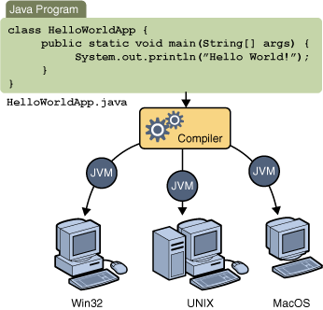
Through the Java VM, the same application is capable of running on multiple platforms.

The Java Platform

A platform is the hardware or software environment in which a program runs. Most platforms can be described as a combination of the operating system and underlying hardware. The Java platform differs from most other platforms in that it's a software-only platform that runs on top of other hardware-based platforms.

The Java platform has two components:

- The Java Virtual Machine (JVM)
- The Java Application Programming Interface (API)

Java Virtual Machine is the base for the Java platform and is ported onto various hardware-based platforms.

The API is a large collection of ready-made software components that provide many useful capabilities. It is grouped into libraries of related classes and interfaces; these libraries are known as packages.
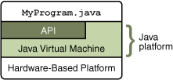
The API and Java Virtual Machine insulate the program from the underlying hardware.
Every full implementation of the Java platform gives you the following features:
- Development Tools: The development tools provide means for compiling, running, debugging, and documenting your applications. The main tools are the javac compiler, the java launcher, and the javadoc documentation tool.

- Application Programming Interface (API): The API provides the core functionality of the Java programming language. It offers a wide array of useful classes ready for use in your own applications. It spans everything from basic objects, to networking and security, to XML generation and database access, etc.

- Deployment Technologies: The JDK software provides standard mechanisms such as the Java Web Start software and Java Plug-In software for deploying your applications to end users.

- User Interface Toolkits: The Swing and Java 2D toolkits make it possible to create sophisticated Graphical User Interfaces (GUIs).

- Integration Libraries: Integration libraries such as the Java IDL, JDBC, JNDI, Java RMI, and Java Remote Method Invocation over Internet Inter-ORB Protocol Technology (Java RMI-IIOP Technology) enable database access and manipulation of remote objects.

